

**An incubated co-working space for technology innovation**

**Internal Document Template**

**Short Report Document**

**Team: Generics**

**Team Register**

|  |  |
| --- | --- |
| **Member Name** | **Role Description** |
| Asandiswa Balekwayo | Raspberry Pi |
| Zimasa Ntikama | Internet of things |
| Msimelelo Bala | Arduino |

**Description of Acronyms**

|  |  |
| --- | --- |
| **Acronym** | **Description** |
| SDN | Software Defined Networking |
| QOS | Quality of service |
| OS | Operating System |
| CLI | Command Line Interface |
| VLAN | Virtual Local Area Network |
| LAN | Local Area Network |
| IP | Internet Protocol |
| IO | Input/output |
| CPU | Central Processing Unit |
| SoC | System on a Chip |

On the first week of May we made a research on Arduino and we also made podcast touching all the important facts on Arduino, like for instance what is Arduino? What does it do? What’s on the board and difference types of Arduino. Below that’s how Arduino research gone. We prepared PowerPoint presentation slides also.

**What is an Arduino?**

**Introduction**

[Arduino](http://arduino.cc/) is an open-source platform used for building electronics projects. Arduino consists of both a physical programmable circuit board (often referred to as a [microcontroller](http://en.wikipedia.org/wiki/Microcontroller)) and a piece of [software](http://arduino.cc/en/Main/Software), or IDE (Integrated Development Environment) that runs on your computer, used to write and upload computer code to the physical board.

The Arduino platform has become quite popular with people just starting out with electronics, and for good reason. Unlike most previous programmable circuit boards, the Arduino does not need a separate piece of hardware (called a programmer) in order to load new code onto the board – you can simply use a USB cable. Additionally, the Arduino IDE uses a simplified version of C++, making it easier to learn to program. Finally, Arduino provides a standard form factor that breaks out the functions of the micro-controller into a more accessible package.

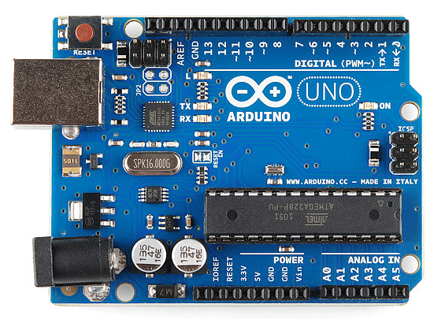

**This Arduino**

The Uno is one of the more popular boards in the Arduino family and a great choice for beginners. We’ll talk about what’s on it and what it can do later in the tutorial.

[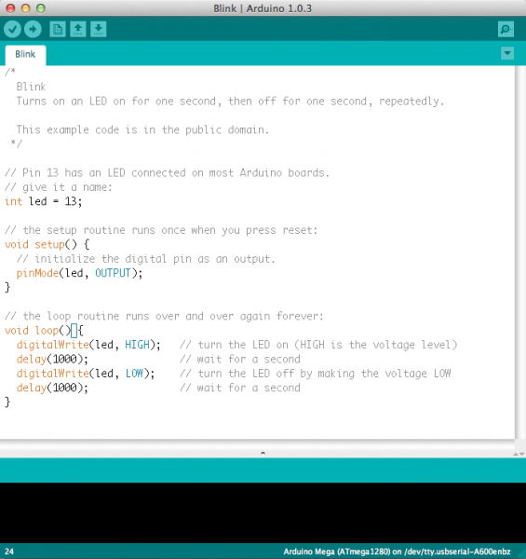](https://cdn.sparkfun.com/assets/a/b/a/f/5/51363844ce395f9922000001.png)

Believe it or not, those 10 lines of code are all you need to blink the on-board LED on your Arduino. The code might not make perfect sense right now, but, after reading this tutorial and the many more Arduino tutorials waiting for you on our site, we’ll get you up to speed in no time!

Suggested Reading

Arduino is a great tool for people of all skill levels. However, you will have a much better time learning alongside your Arduino if you understand some basic fundamental electronics beforehand. We recommend that you have at least a decent understanding of these concepts before you dive in to the wonderful world of Arduino.

* [What is Electricity?](https://learn.sparkfun.com/tutorials/what-is-electricity)
* [Voltage, Current, Resistance, and Ohm’s Law](https://learn.sparkfun.com/tutorials/voltage-current-resistance-and-ohms-law)
* [What is a Circuit?](https://learn.sparkfun.com/tutorials/what-is-a-circuit)
* [Polarity](https://learn.sparkfun.com/tutorials/polarity)
* [Integrated Circuits (ICs)](https://learn.sparkfun.com/tutorials/integrated-circuits)
* [Logic Levels](https://learn.sparkfun.com/tutorials/logic-levels)
* [Digital Logic](https://learn.sparkfun.com/tutorials/digital-logic)
* [Analog vs. Digital](https://learn.sparkfun.com/tutorials/analog-vs-digital)

**What Does it Do?**

The Arduino hardware and software was designed for artists, designers, hobbyists, hackers, newbies, and anyone interested in creating interactive objects or environments. Arduino can interact with buttons, LEDs, motors, speakers, GPS units, cameras, the internet, and even your smart-phone or your TV! This flexibility combined with the fact that the Arduino software is free, the hardware boards are pretty cheap, and both the software and hardware are easy to learn has led to a large community of users who have contributed code and released instructions for a **huge** variety of Arduino-based projects.

For everything from [robots](https://learn.sparkfun.com/tutorials/building-the-hub-ee-buggy) and a [heating pad hand warming blanket](https://learn.sparkfun.com/tutorials/heating-pad-hand-warmer-blanket) to [honest fortune-telling machines](https://learn.sparkfun.com/tutorials/the-uncertain-7-cube), and even a [Dungeons and Dragons dice-throwing gauntlet](http://www.sparkfun.com/tutorials/333), the Arduino can be used as the brains behind almost any electronics project.



Wear your nerd cred on your sleever, arm.

And that’s really just the tip of the iceberg – if you’re curious about where to find more examples of Arduino projects in action, here are some good resources for Arduino-based projects to get your creative juices flowing:

* [Instructables](http://www.instructables.com/tag/type-id/category-technology/channel-arduino/)
* [Bildr](http://bildr.org/category/tutorials/)
* [Arduino Playground](http://playground.arduino.cc/)
* [The ITP Physical Computing Wiki](http://itp.nyu.edu/physcomp/Tutorials/Tutorials)
* [LadyAda](http://www.ladyada.net/make/)

**What's on the board?**

There are many varieties of Arduino boards ([explained on the next page](https://learn.sparkfun.com/tutorials/what-is-an-arduino/the-arduino-family)) that can be used for different purposes. Some boards look a bit different from the one below, but most Arduinos have the majority of these components in common:

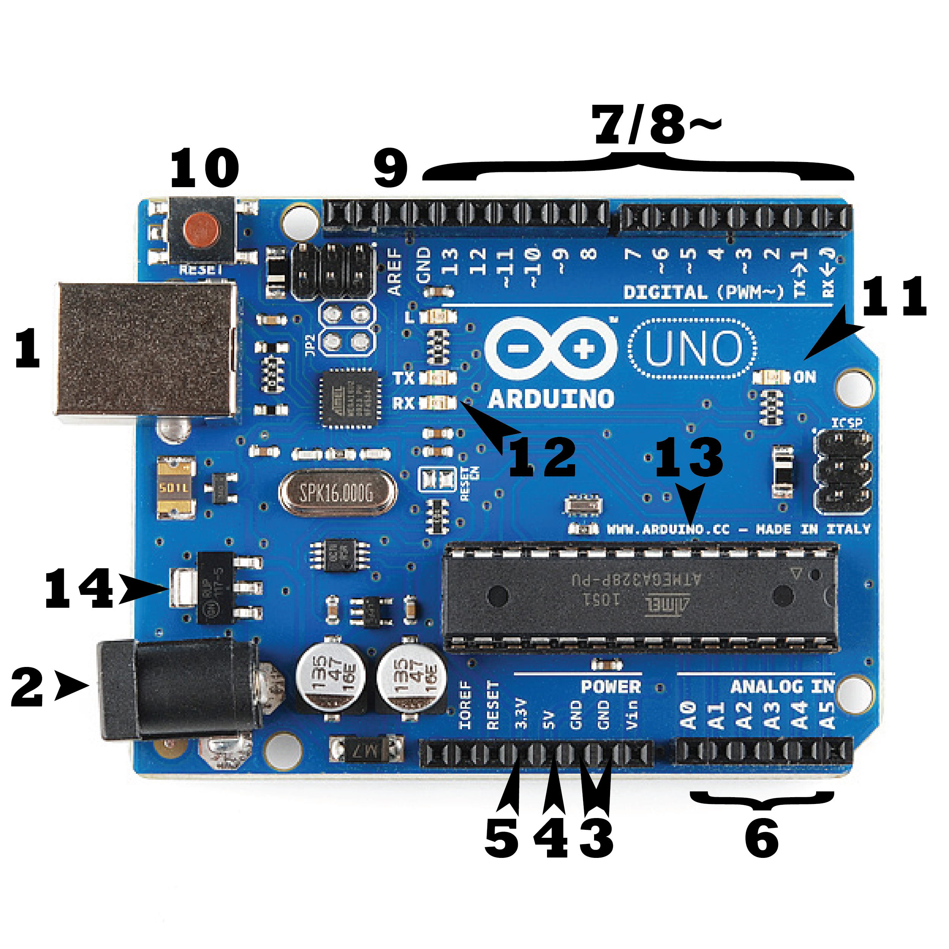

**Power (USB / Barrel Jack)**

Every Arduino board needs a way to be connected to a power source. The Arduino UNO can be powered from a USB cable coming from your computer or a wall power supply ([like this](https://www.sparkfun.com/products/8269)) that is terminated in a barrel jack. In the picture above the USB connection is labeled **(1)** and the barrel jack is labeled **(2)**.

The USB connection is also how you will load code onto your Arduino board. More on how to program with Arduino can be found in our [Installing and Programming Arduino](https://learn.sparkfun.com/tutorials/installing-arduino-ide) tutorial.

**NOTE:** Do NOT use a power supply greater than 20 Volts as you will overpower (and thereby destroy) your Arduino. The recommended voltage for most Arduino models is between 6 and 12 Volts.

Pins (5V, 3.3V, GND, Analog, Digital, PWM, AREF)

The pins on your Arduino are the places where you connect wires to construct a circuit (probably in conjuction with a [breadboard](https://learn.sparkfun.com/tutorials/how-to-use-a-breadboard/) and some [wire](https://learn.sparkfun.com/tutorials/working-with-wire). They usually have black plastic ‘headers’ that allow you to just plug a wire right into the board. The Arduino has several different kinds of pins, each of which is labeled on the board and used for different functions.

* **GND (3)**: Short for ‘Ground’. There are several GND pins on the Arduino, any of which can be used to ground your circuit.
* **5V (4) & 3.3V (5)**: As you might guess, the 5V pin supplies 5 volts of power, and the 3.3V pin supplies 3.3 volts of power. Most of the simple components used with the Arduino run happily off of 5 or 3.3 volts.
* **Analog (6)**: The area of pins under the ‘Analog In’ label (A0 through A5 on the UNO) are Analog In pins. These pins can read the signal from an analog sensor (like a [temperature sensor](https://www.sparkfun.com/products/10988)) and convert it into a digital value that we can read.
* **Digital (7)**: Across from the analog pins are the digital pins (0 through 13 on the UNO). These pins can be used for both digital input (like telling if a button is pushed) and digital output (like powering an LED).
* **PWM (8)**: You may have noticed the tilde (~) next to some of the digital pins (3, 5, 6, 9, 10, and 11 on the UNO). These pins act as normal digital pins, but can also be used for something called Pulse-Width Modulation (PWM). We have [a tutorial on PWM](https://learn.sparkfun.com/tutorials/pulse-width-modulation), but for now, think of these pins as being able to simulate analog output (like fading an LED in and out).
* **AREF (9)**: Stands for Analog Reference. Most of the time you can leave this pin alone. It is sometimes used to set an external reference voltage (between 0 and 5 Volts) as the upper limit for the analog input pins.

Reset Button

Just like the original Nintendo, the Arduino has a reset button **(10)**. Pushing it will temporarily connect the reset pin to ground and restart any code that is loaded on the Arduino. This can be very useful if your code doesn’t repeat, but you want to test it multiple times. Unlike the original Nintendo however, blowing on the Arduino doesn’t usually fix any problems.

Power LED Indicator

Just beneath and to the right of the word “UNO” on your circuit board, there’s a tiny LED next to the word ‘ON’ **(11)**. This LED should light up whenever you plug your Arduino into a power source. If this light doesn’t turn on, there’s a good chance something is wrong. Time to re-check your circuit!

TX RX LEDs

TX is short for transmit, RX is short for receive. These markings appear quite a bit in electronics to indicate the pins responsible for [serial communication](https://learn.sparkfun.com/tutorials/serial-communication). In our case, there are two places on the Arduino UNO where TX and RX appear – once by digital pins 0 and 1, and a second time next to the TX and RX indicator LEDs **(12)**. These LEDs will give us some nice visual indications whenever our Arduino is receiving or transmitting data (like when we’re loading a new program onto the board).

**Main IC**

The black thing with all the metal legs is an IC, or Integrated Circuit **(13)**. Think of it as the brains of our Arduino. The main IC on the Arduino is slightly different from board type to board type, but is usually from the ATmega line of IC’s from the ATMEL company. This can be important, as you may need to know the IC type (along with your board type) before loading up a new program from the Arduino software. This information can usually be found in writing on the top side of the IC. If you want to know more about the difference between various IC’s, reading the datasheets is often a good idea.

Voltage Regulator

The voltage regulator **(14)** is not actually something you can (or should) interact with on the Arduino. But it is potentially useful to know that it is there and what it’s for. The voltage regulator does exactly what it says – it controls the amount of voltage that is let into the Arduino board. Think of it as a kind of gatekeeper; it will turn away an extra voltage that might harm the circuit. Of course, it has its limits, so don’t hook up your Arduino to anything greater than 20 volts.

**The Arduino Family**

Arduino makes several different boards, each with different capabilities. In addition, part of being open source hardware means that others can modify and produce derivatives of Arduino boards that provide even more form factors and functionality. If you’re not sure which one is right for your project, [check this guide](https://www.sparkfun.com/arduino_guide) for some helpful hints. Here are a few options that are well-suited to someone new to the world of Arduino:

[Arduino Uno (R3)](https://www.sparkfun.com/products/11021)

The Uno is a great choice for your first Arduino. It’s got everything you need to get started, and nothing you don’t. It has 14 digital input/output pins (of which 6 can be used as PWM outputs), 6 analog inputs, a USB connection, a power jack, a reset button and more. It contains everything needed to support the microcontroller; simply connect it to a computer with a USB cable or power it with a AC-to-DC adapter or battery to get started.



[**LilyPad Arduino**](https://www.sparkfun.com/products/9266)

This is LilyPad Arduino main board! LilyPad is a wearable e-textile technology developed by [Leah Buechley](http://web.media.mit.edu/~leah/) and cooperatively designed by Leah and SparkFun. Each LilyPad was creatively designed with large connecting pads and a flat back to allow them to be [sewn into clothing](https://learn.sparkfun.com/tutorials/sewing-with-conductive-thread) with conductive thread. The LilyPad also has its own family of input, output, power, and sensor boards that are also built specifically for e-textiles. They’re even washable!

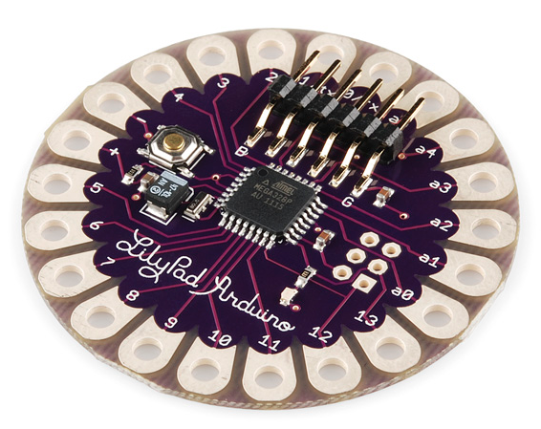

[**RedBoard**](https://www.sparkfun.com/products/11575)

At SparkFun we use many Arduinos and we’re always looking for the simplest, most stable one. Each board is a bit different and no one board has everything we want – so we decided to make our own version that combines all our favorite features.

The RedBoard can be programmed over a USB Mini-B cable using the Arduino IDE. It’ll work on Windows 8 without having to change your security settings (we used signed drivers, unlike the UNO). It’s more stable due to the USB/FTDI chip we used, plus it’s completely flat on the back, making it easier to embed in your projects. Just plug in the board, select “Arduino UNO” from the board menu and you’re ready to upload code. You can power the RedBoard over USB or through the barrel jack. The on-board power regulator can handle anything from 7 to 15VDC.

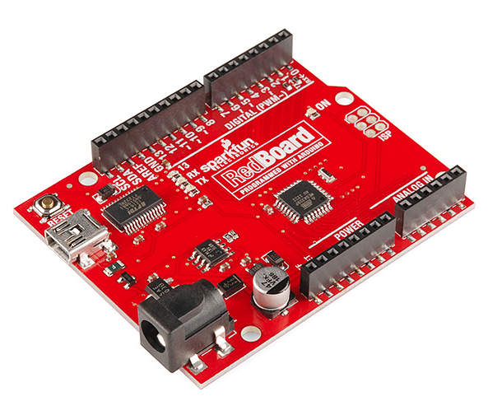

[**Arduino Mega (R3)**](https://www.sparkfun.com/products/11061)

The Arduino Mega is like the UNO’s big brother. It has lots (*54!*) of digital input/output pins (14 can be used as PWM outputs), 16 analog inputs, a USB connection, a power jack, and a reset button. It contains everything needed to support the microcontroller; simply connect it to a computer with a USB cable or power it with a AC-to-DC adapter or battery to get started. The large number of pins make this board very handy for projects that require a bunch of digital inputs or outputs (like lots of LEDs or buttons).

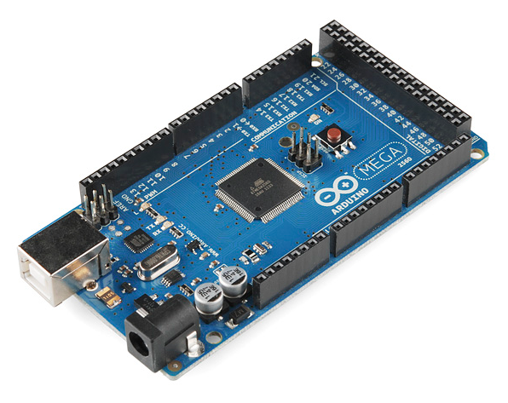

[**Arduino Leonardo**](https://www.sparkfun.com/products/11286)

The Leonardo is Arduino’s first development board to use one microcontroller with built-in USB. This means that it can be cheaper and simpler. Also, because the board is handling USB directly, code libraries are available which allow the board to emulate a computer keyboard, mouse, and more!

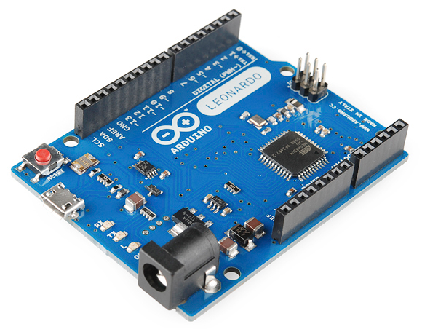[](https://cdn.sparkfun.com/assets/3/2/0/f/1/515b5745ce395fc83c000001.png)

**The Extended Family**

While your Arduino board sure is pretty, it can’t do a whole lot on its own – you’ve got to hook it up to something. There are lots of tutorials here on learn as well as the links back in the ‘What does it do’ section, but rarely do we talk about the general *kinds* of things you can easily hook into. In this section we’ll introduce basic **sensors** as well as Arduino **shields**, two of the most handy tools to use in bringing your projects to life.

Sensors

With some simple code, the Arduino can control and interact with a wide variety of **sensors** - things that can measure [light](https://www.sparkfun.com/products/9088), [temperature](https://www.sparkfun.com/products/10988), [degree of flex](https://www.sparkfun.com/products/8606), [pressure](https://www.sparkfun.com/products/11207), [proximity](https://www.sparkfun.com/products/242), [acceleration](https://www.sparkfun.com/products/9836), [carbon monoxide](https://www.sparkfun.com/products/9403?_ga=1.230952796.2101465200.1432371452), [radioactivity](https://www.sparkfun.com/products/11345), [humidity](https://www.sparkfun.com/products/9569), [barometric pressure](https://www.sparkfun.com/products/9721), [you name it](https://www.sparkfun.com/products/11574), [you can sense it](https://www.sparkfun.com/products/9964)!

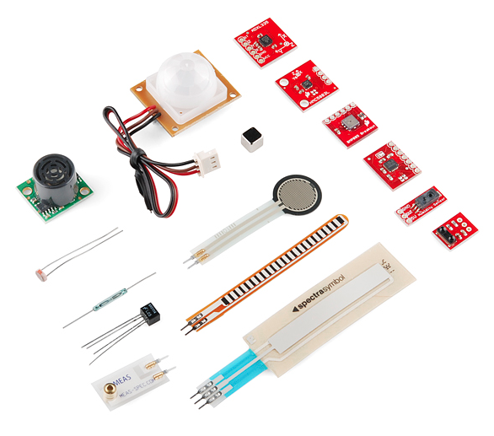**Shields**

Additionally, there are these things called **shields** – basically they are pre-built circuit boards that fit on top of your Arduino and provide additional capabilities – [controlling motors](https://www.sparkfun.com/products/9815), [connecting to the internet](https://www.sparkfun.com/products/9026), [providing cellular](https://www.sparkfun.com/products/9607) or [other wireless communication](https://www.sparkfun.com/products/11018), [controlling an LCD screen](https://www.sparkfun.com/products/9363), and [much more](https://www.sparkfun.com/products/9595).

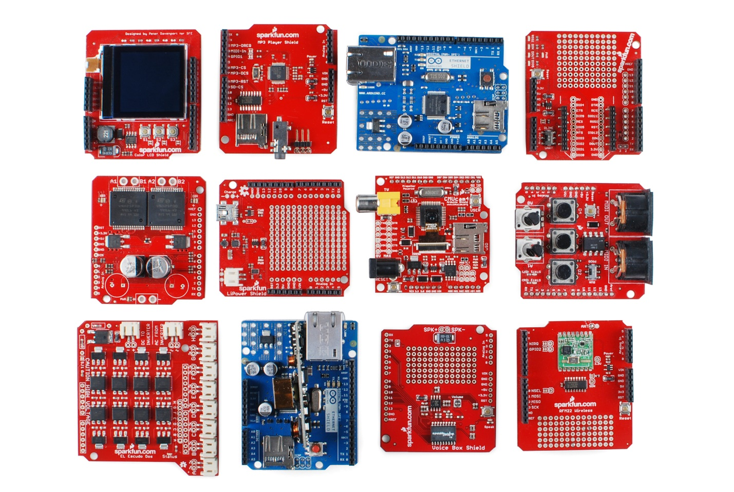

We also worked on Raspberry pi checking what is it, what’s the big deal about it, cool things you can go with raspberry pi, components and its requirements. We made podcasts which were based on the key words above. We prepared PowerPoint presentation slides also. Below is our raspberry pi research.

**Raspberry Pi**

Is a single board computer developed by raspberry pi foundation in UK released in February 2012.

The Raspberry Pi is a low cost, credit-card sized computer that plugs into a computer monitor or TV, and uses a standard keyboard and mouse.

It is a capable little device that enables people of all ages to explore computing, and to learn how to program in languages like Scratch and Python. It’s capable of doing everything you’d expect a desktop computer to do, from browsing the internet and playing high-definition video, to making spreadsheets, word-processing, and playing games.

What’s more, the Raspberry Pi has the ability to interact with the outside world, and has been used in a wide array of digital maker projects, from music machines and parent detectors to weather stations and tweeting birdhouses with infra-red cameras. We want to see the Raspberry Pi being used by kids all over the world to learn to program and understand how computers work.

**What’s the big deal?**

There are several reasons why the Raspberry Pi is a big deal. For the technology community, this illustrates that the super cheap and ultra-affordable PC is indeed a reality. For those wanting to learn more about technology and developing it, doing so is now more affordable and accessible than ever. At the cost of a textbook, nearly everyone should be able to get a Raspberry Pi if they have the desire to learn and to potentially pursue new opportunities.

**Hardware**

* Schematics
  + Schematics for the Raspberry Pi Model A, B and B+
* BCM2835/BCM2836
  + The Broadcom processors used in Raspberry Pi
* Mechanical Drawings
  + Mechanical drawings of the Raspberry Pi Model B+
* Power
  + Powering the Raspberry Pi
  + 1.5 W (model A), 1.0 W (model A+), 3.5 W (model B) or 3.0 W (model B+)
* USB
  + USB on the Raspberry Pi
* GPIO
  + General Purpose Input/Output pins on the Raspberry Pi
* **SPI** 
  + **SPI on the Raspberry Pi**

**RAM**

On the older beta model B boards, 128 MB was allocated by default to the GPU, leaving 128 MB for the CPU. On the first 256 MB release model B (and model A), three different splits were possible. The default split was 192 MB (RAM for CPU), which should be sufficient for standalone 1080p video decoding, or for simple 3D, but probably not for both together.

224 MB was for Linux only, with just a 1080p frame buffer, and was likely to fail for any video or 3D. 128 MB was for heavy 3D, possibly also with video decoding (e.g. XBMC). Comparatively the Nokia 701 uses 128 MB for the Broadcom Video Core IV. For the new model B with 512 MB RAM initially there were new standard memory split files released( arm256_start.elf, arm384_start.elf, arm496_start.elf) for 256 MB, 384 MB and 496 MB CPU RAM (and 256 MB, 128 MB and 16 MB video RAM).

But a week or so later the RPF released a new version of start. elf that could read a new entry in config.txt (gpu_mem=xx) and could dynamically assign an amount of RAM (from 16 to 256 MB in 8 MB steps) to the GPU, so the older method of memory splits became obsolete, and a single start. elf worked the same for 256 and 512 MB Pis. The second generation has 1 GB of RAM

**Networking**

Though the model A and A+ do not have an 8P8C ("RJ45") Ethernet port, they can be connected to a network using an external user-supplied USB Ethernet or Wi-Fi adapter. On the model B and B+ the Ethernet port is provided by a built-in USB Ethernet adapter.

**Peripherals**

Generic USB keyboards and mice are compatible with the Raspberry Pi.[9]

**Video**

The video controller is capable of standard modern TV resolutions, such as HD and Full HD, and higher or lower monitor resolutions and older standard CRT TV resolutions; capable of the following: 640×350 EGA; 640×480 VGA; 800×600 SVGA; 1024×768 XGA; 1280×720 720p HDTV; 1280×768 WXGA variant; 1280×800 WXGA variant; 1280×1024 SXGA; 1366×768 WXGA variant; 1400×1050 SXGA+; 1600×1200 UXGA; 1680×1050 WXGA+; 1920×1080 1080p HDTV; 1920×1200 WUXGA. It can generate 576i and 480i composite video signals for PAL-BGHID, PAL-M, PAL-N, NTSC and NTSC-J.

**Accessories**

**Camera** – On 14 May 2013, the foundation and the distributors RS Components & Premier Farnell/Element 14 launched the Raspberry Pi camera board with a firmware update to accommodate it. The camera board is shipped with a flexible flat cable that plugs into the CSI connector located between the Ethernet and HDMI ports. In Raspbian, one enables the system to use the camera board by the installing or upgrading to the latest version of the operating system (OS) and then running Raspi-config and selecting the camera option. The cost of the camera module is €20 in Europe (9 September 2013). It can produce 1080p, 720p, 640x480p video. The footprint dimensions are 25 mm x 20 mm x 9 mm.

**Gertboard** – A Raspberry Pi Foundation sanctioned device, designed for educational purposes, that expands the Raspberry Pi's GPIO pins to allow interface with and control of LEDs, switches, analog signals, sensors and other devices. It also includes an optional Arduino compatible controller to interface with the Pi.

**Infrared Camera** – In October 2013, the foundation announced that they would begin producing a camera module without an infrared filter, called the Pi NoIR.

**HAT (Hardware Attached on Top) expansion boards** – Together with the model B+, inspired by the Arduino shield boards, the interface for HAT boards was devised by the Raspberry PI Foundation. Each HAT board carries a small EEPROM (typically a CAT24C32WI-GT3) containing the relevant details of the board, so that the Raspberry PI's OS is informed of the HAT, and the technical details of it, relevant to the OS using the HAT. Mechanical details of a HAT board, that use the four mounting holes in their rectangular formation.

**MEMORY**

256 MB (model A, A+, B rev 1)  
512 MB (model B rev 2, B+, CM)

**Software**

**Operating systems**

The Raspberry Pi primarily uses Linux-kernel-based operating systems.

The ARM11 chip at the heart of the Pi (first generation models) is based on version 6 of the ARM. The current releases of several popular versions of Linux, including Ubuntu, will not run on the ARM11. It is not possible to run Windows on the original Raspberry Pi, though the new Raspberry Pi 2 will be able to run Windows 10.

**Cool Things You Can Go with Raspberry Pi**

**Learn to program**

The RPI makes for a great programming platform, with a huge choice of languages available.

**Scratch the Pi**

Scratch is the programming language that’s easy to get to grips with and easy to use which makes it good for children to start learning with and for creating rich programming projects.

**Spectrum BASIC for RPi**

Although you can play Spectrum games via emulator, programming BASIC through the emulator just isn’t the same. That being the case, use SpecBAS instead.

**Pi Hacker**

Being as small as it is the RPi would make an excellent hacking tool. Regardless of ethics involved.

**Firefox OS on Pi**

Although still the development stages, Oleg Romashin an engineer at Nokia has managed to get Firefox OS running on the Raspberry Pi. FFOS is not out officially.

**RISC OS for Pi**

If you fancy a blast from the past, then give RISC OS for the RPi a try

**Beer can keyboard**

Keyboard can be made from beer cans the Robofun team hooked up an arduino board to a raspberry Pi along with cans of beer.40 beers cans were connected to an arduino powered touch capacitive controller forming a keyboard

**RPi weather station**

Would make an excellent science project for school, the Raspberry Pi weather station .Using a Maplin bought USB Wireless Touch Weather Station, the RPi can log all relevant data.

**10-inch RPI Touchscreen**

Using a 10-inch capacitive touchscreen and HDMI-LVDS converter you can create a touchscreen Raspberry Pi.

**Home Automation**

There’s a new product called PiFace that’s perfect for home automation. It hooks up to the RPi and allows it to detect switch states from a door sensor, a pressure pad or any number of other switch types.

**Robotics**

Robots are generally quite cool , obviously aside from the ones that wish to except for the ones that try to kill all of humanity. Online magazine RPi MagPi has a feature about how to make a robotic arm work with the RPi.

**Raspberry Pi model A and B Hardware specification**

| **Model A** | **Model B** |
| --- | --- |
|  | [Raspberry Pi Model A](http://www.raspberrypi-spy.co.uk/2013/02/introducing-the-raspberry-pi-model-a/raspberry_pi_model_a_04/) | [Model B](http://www.raspberrypi-spy.co.uk/2012/09/raspberry-pi-revision-2-0-photos/raspberry_pi_model_b_rev2_12/) |
| Price | US$25 (GBP £20) | US$35 (GBP £28) |
| System (SoC) | Broadcom BCM2835 (CPU + GPU + SDRAM) | |
| CPU | 700 MHz ARM11 ARM1176JZF-S core | |
| GPU | Broadcom Video Core IV, OpenGL ES 2.0, OpenVG 1080p30 H.264 high-profile encode/decode | |
| Memory | 256 MB | 512 MB |
| USB 2.0 ports | 1 | 2 |
| Video outputs | Composite video, Composite RCA, HDMI | |
| Audio outputs | 3.5 mm jack, HDMI Audio | |
| Audio inputs | None | |
| Storage | SD/SDHC card slot | |
| Network | None | 10/100 Ethernet RJ45 |
| Low-level peripherals | General Purpose Input/ Output (GPIO) pins, Serial Peripheral Interface Bus (SPI), I²C, I²S, Universal asynchronous receiver/transmitter (UART) | |
| Real-time clock | None | |
| Power ratings | 500mA, (2.5 Watt) | 700mA, (3.5 Watt) |
| Power source | 5V via Micro USB connector | |
| Size | 85mm x 56mm (more [mechanical details here](http://www.raspberrypi-spy.co.uk/2012/03/mechanical-data-dimensions/)) | |

**Using a Breadboard**

A breadboard is a very useful device for prototyping circuits. It allows you to easily plug in and remove components and so if there are going to be many changes or if you just want to make a circuit quickly, it will be much quicker than soldering up your circuit.

**Requirements**:

**Raspberry Pi**

The Raspberry Pi is the main component of all examples on this website. It contains an ARM processor which does all of the computation, and a wide variety of The Raspberry Pi is the main component of all examples on this website. It contains an ARM processor which does all of the computation, and a wide variety of input and output ports to allow it to communicate with the outside world.

**Ribbon cable**

A ribbon cable is used to connect the Raspberry Pi’s GPIO pins to a breadboard, making it easier to connect external components. One end of the ribbon cable plugs directly into the Raspberry Pi (with the red stripe nearest the edge of the board), and the other end plugs into a breakout board, which is in turn connected to a breadboard. There can also be intermediate plugs allowing multiple breakout boards to be connected.

If you do not have a ribbon cable, it is possible to plug wires and components directly into the Pi’s GPIO pins.

**Breakout Board**

A breakout board is used to connect a ribbon cable to a breadboard, allowing larger circuits to be prototyped more easily. The two rows of pins on the breakout board should go on either side of the central divide on the breadboard

**Breadboard**

A breadboard has many holes, normally spaced 0.1” apart that you can insert leads/wires into that will be held in place by metal contacts inside. This allows fast prototyping of circuits, without the need to solder anything together.

There are many columns (often numbered) which are logically a single point (i.e. they are all connected together internally). There is normally a bridge in the centre; this separates one side from the other, both in terms of space and connectivity. If attaching a breakout board, its two rows of pins should go on opposite sides of this bridge.

Side view of transparent breadboard showing the internal connections of the clips.

A breadboard will normally have two long rows (sometimes two each side) that run the whole board length (or should be clearly marked if in sections) that are designed to provide easy access to ground and power, these are normally referred to as power rails.

**Jumper wires**

Jumper wires are used to make it easier to manage circuits built on a breadboard. They allow the components of the circuit to be spread out more, allowing easier access, and also allows them to be laid out in a more logical fashion. The wires are usually cut to lengths such that they fit neatly between two holes in the breadboard, but it is easy enough to create your own using a length of wire and some wire strippers

**LED**

An LED is a very simple electronics component which lights up when electricity flows through it. Since it is a diode, electricity can only flow one way. There is usually a flat section on the side of the LED to mark its polarity: this side should be connected to ground. This side usually also has a shorter “leg”.

In order to prevent too much current flowing through an LED and damaging it, it should be connected in series with a resistor. See here for information on how to select an appropriate resistor.

**Resistor**

Resistors are used to change the amount of current flowing through a part of the circuit. This is often used as a means of protecting components which cannot handle large currents.

The current allowed to flow through a resistor can be calculated using: I = V/R (current = voltage/resistance).

There are many different resistors available, so they have a sequence of coloured stripes to show their resistance. See here for details on how to decipher the colour coding.

As we working on embedded systems such as raspberry pi and Arduino we find it vital that we also search something on the IoT since we are going to produced something based on it. We also made podcasts of IoT introduction, history of it, applications, trends & characteristics, use of IoT, the IoT and technology, how businesses fit into IoT, wearables & IoT, Are the big enterprises ready for Internet of thing and also IoT technologies.

**INTERNET OF THINGS**

The Internet of Things (IoT) is the network of physical objects or things embedded with electronics, software, sensors and connectivity to enable it to achieve greater value and service by exchanging data with the manufacturer, operator and/or other connected devices. Each thing is uniquely identifiable through its embedded computing system but is able to interoperate within the existing Internet infrastructure.

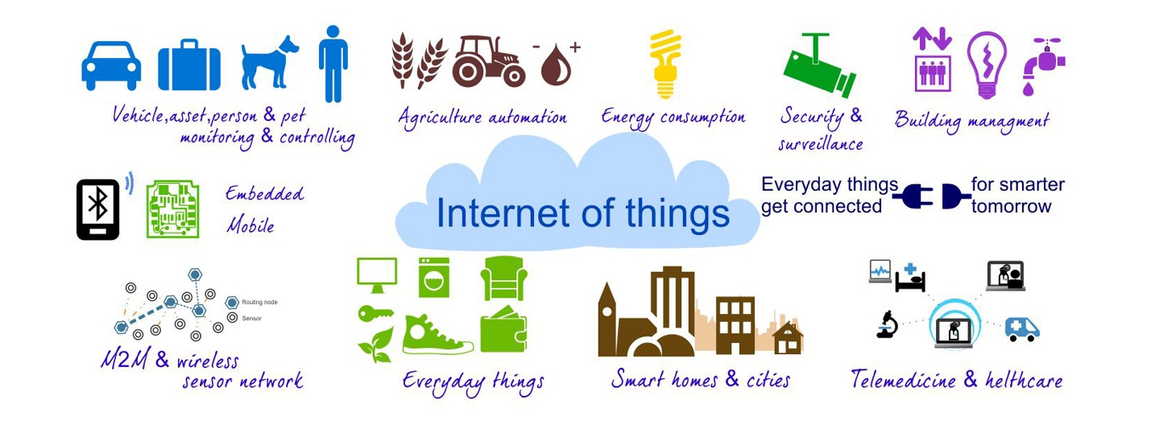

The term Internet of Things was first documented by a British visionary, Kevin Ashton, in 1999. Typically, IoT is expected to offer advanced connectivity of devices, systems, and services that goes beyond machine-to-machine communications (M2M) and covers a variety of protocols, domains, and applications

**EARLY HISTORY**

As of 2014, the vision of the Internet of Things has evolved due to a convergence of multiple technologies, ranging from wireless communication to the Internet and from embedded systems to micro-electromechanical systems (MEMS). This means that the traditional fields of embedded systems, wireless sensor networks, control systems, automation (including home and building automation), and others all contribute to enabling the Internet of Things (IoT)

The concept of the Internet of Things first became popular in 1999, through the Auto-ID Center at MIT and related market-analysis publications. Radio-frequency identification (RFID) was seen as a prerequisite for the Internet of Things in the early days. If all objects and people in daily life were equipped with identifiers, computers could manage and inventory them

**APPLICATIONS**

According to Gartner, Inc. (a technology research and advisory corporation), there will be nearly 26 billion devices on the Internet of Things by 2020. ABI Research estimates that more than 30 billion devices will be wirelessly connected to the Internet of Things (Internet of Everything) by 2020.

Integration with the Internet implies that devices will utilize an IP address as a unique identifier. However, due to the limited address space of IPv4 (which allows for 4.3 billion unique addresses), objects in the IoT will have to use IPv6 to accommodate the extremely large address space required.  Objects in the IoT will not only be devices with sensory capabilities, but also provide actuation capabilities (e.g., bulbs or locks controlled over the Internet). To a large extent, the future of the Internet of Things will not be possible without the support of IPv6; and consequently the global adoption of IPv6 in the coming years will be critical for the successful development of the IoT in the future.

The ability to network embedded devices with limited CPU, memory and power resources means that IoT finds applications in nearly every field. Such systems could be in charge of collecting information in settings ranging from natural ecosystems to buildings and factories, thereby finding applications in fields of environmental sensing and urban planning

The application of the IoT is not only restricted to these areas. Other specialized use cases of the IoT may also exist. An overview of some of the most prominent application areas is provided here. Based on the application domain, IoT products can be classified broadly into five different categories: smart wearable, smart home, smart city, smart environment, and smart enterprise. The IoT products and solutions in each of these markets have different characteristics

* Media
* Environmental monitoring
* Infrastructure management
* Manufacturing
* Energy management
* Medical and healthcare systems
* Building and home automation
* Transportation
* Large scale deployments

**MEDIA**

The Media and Big Data are interconnected, it is first necessary to provide some context into the mechanism used for media process.

The ultimate aim is of course to serve, or convey, a message or content that is (statistically speaking) in line with the consumer's mindset. For example, publishing environments are increasingly tailoring messages (advertisements) and content (articles) to appeal to consumers that have been exclusively gleaned through various data-mining activities

The media industries process Big Data in a dual, interconnected manner:

* Targeting of consumers (for advertising by marketers)
* Data-capture

Thus, the internet of things creates an opportunity to measure, collect and analyze an ever-increasing variety of behavioral statistics. Cross-correlation of this data could revolutionize the targeted marketing of products and services

Big Data and the IoT work in conjunction. From a media perspective, Data is the key derivative of device inter connectivity, whilst being pivotal in allowing clearer accuracy in targeting. The Internet of Things therefore transforms the media industry, companies and even governments, opening up a new era of economic growth and competitiveness

**ENVIRONMENTAL MONITORING**

Environmental monitoring applications of the IoT typically utilize sensors to assist in environmental protection by monitoring air or water quality, atmospheric or soil conditions, and can even include areas like monitoring the movements of wildlife and their habitats. Development of resourceconstrained devices connected to the Internet also means that other applications like earthquake or tsunami early-warning systems can also be used by emergency services to provide more effective aid. IoT devices in this application typically span a large geographic area and can also be mobile

**INFRASTRUCTURE MANAGEMENT**

Monitoring and controlling operations of urban and rural infrastructures like bridges, railway tracks, on- and offshore- wind-farms is a key application of the IoT. The IoT infrastructure can be used for monitoring any events or changes in structural conditions that can compromise safety and increase risk. It can also be utilized for scheduling repair and maintenance activities in an efficient manner, by coordinating tasks between different service providers and users of these facilities. IoT devices can also be used to control critical infrastructure like bridges to provide access to ships. Usage of IoT devices for monitoring and operating infrastructure is likely to improve incident management and emergency response coordination, and quality of service, up-times and reduce costs of operation in all infrastructure related areas

**MANUFACTURING**

Network control and management of manufacturing equipment, asset and situation management, or manufacturing process control bring the IoT within the realm on industrial applications and smart manufacturing as well. The IoT intelligent systems enable rapid manufacturing of new products, dynamic response to product demands, and real-time optimization of manufacturing production and supply chain networks, by networking machinery, sensors and control systems together.

**ENERGY MANAGEMNT**

Integration of sensing and actuation systems, connected to the Internet, is likely to optimize energy consumption as a whole. It is expected that IoT devices will be integrated into all forms of energy consuming devices (switches, power outlets, bulbs, televisions, etc.) and be able to communicate with the utility supply company in order to effectively balance power generation and energy usage. Such devices would also offer the opportunity for users to remotely control their devices, or centrally manage them via a cloud based interface, and enable advanced functions like scheduling (e.g., remotely powering on or off heating systems, controlling ovens, changing lighting conditions

The IoT is especially relevant to the Smart Grid since it provides systems to gather and act on energy and power-related information in an automated fashion with the goal to improve the efficiency, reliability, economics, and sustainability of the production and distribution of electricity.

**MEDICAL AND HEALTHCARE SYSTEMS**

IoT devices can be used to enable remote health monitoring and emergency notification systems. These health monitoring devices can range from blood pressure and heart rate monitors to advanced devices capable of monitoring specialized implants, such as pacemakers or advanced hearing aids.

Specialized sensors can also be equipped within living spaces to monitor the health and general well-being of senior citizens, while also ensuring that proper treatment is being administered and assisting people regain lost mobility via therapy as well. Other consumer devices to encourage healthy living, such as, connected scales or wearable heart monitors, are also a possibility with the IoT

**BUILDING AND HOME AUTOMATION**

IoT devices can be used to monitor and control the mechanical, electrical and electronic systems used in various types of buildings (e.g., public and private, industrial, institutions, or residential). Home automation systems, like other building automation systems, are typically used to control lighting, heating, ventilation, air conditioning, appliances, communication systems, entertainment and home security devices to improve convenience, comfort, energy efficiency, and security

**TRANSPOTATION**

The IoT can assist in integration of communications, control, and information processing across various transportation systems. Application of the IoT extends to all aspects of transportation systems, i.e. the vehicle, the infrastructure, and the driver or user. Dynamic interaction between these components of a transport system enables inter and intra vehicular communication, smart traffic control, smart parking, electronic toll collection systems, logistic and fleet management, vehicle control and safety and road assistance

**LARGE SCALE DEPLOYMENTS**

There are several planned or ongoing large-scale deployments of the IoT, to enable better management of cities and systems. To enable better management of cities and systems. For example, Songdo, South Korea, the first of its kind fully equipped and wired smart city, is near completion. Nearly everything in this city is planned to be wired, connected and turned into a constant stream of data that would be monitored and analyzed by an array of computers with little, or no human intervention

Another application is a currently undergoing project in Santander, Spain. For this deployment, two approaches have been adopted. This city of 180000 inhabitants, has already seen 18000 city application downloads for their smartphones.

**TRENDS AND CHARACRERISTICS**

* Intelligence
* Architecture
* Complex system
* Size considerations
* Space considerations
* Sectors
* A Basket of Remotes

**WHAT’S THE USE OF IoT?**

The most advanced uses of the IoT probably have yet to be thought of. But there are essentially six immediate scenarios that it enables:

* You can connect with things in a completely new way, learning about them simply by scanning them with our phone or other device.
* You can monitor things remotely in a holistic way, bringing together multiple inputs to give better control of the world around us.
* You can search for things. Imagine typing ‘Where are my keys’ into Google and getting a sensible answer.
* You can manage things better, from traffic flows to use of energy within the home or business.
* You can control things, such as smart thermostats from anywhere in the world
* You can play with things. Imagine augmented reality communicating with the world around you to make gaming truly real.

So what does this mean in terms of actual, concrete examples? Again, these are split into five main areas:

**Smart cities**: over half the world’s population lives in cities. From the bus that knows exactly where it is and gives real-time arrival time to streetlights that dim when there’s no-one near, the Internet of Things promises to deliver greater control and efficiency to the chaos of modern city living.

**Health:** By 2017 we’ll be using over 80 million wearable health sensors worldwide, mostly for sports and fitness. And around the globe 2.5 million patients already have medical monitoring devices. Shrinking these sensors and connecting them to the internet can be a life saver. Imagine a chip that analyses your blood and warns your doctor if vital signs change or a tracks what a dementia patient is doing. The Internet of Things should help manage a rapidly aging population with finite medical resources.

**The smart home:** Probably the area that has seen the greatest penetration to date is within the home. Companies such as Alert Me offer sensors to control objects inside the house, from monitoring energy consumption to changing your heating settings remotely via your smartphone.

**THE IOT AND TECHNOLOG**

At a basic level the technology behind the Internet of Things is already here. Embedded wireless sensors are all around us, communicating with each other via the Cloud and often controlled through our smartphones. But scaling this requires progress in many key areas:

**Power**: 50 billion devices can’t rely on traditional battery or mains power. Devices need to be ultra-low power and able to survive for their whole lifetime without the batteries needing to be changed. Companies such as ARM and TTP are investing heavily in this area, both to reduce the power needs of devices and to develop techniques such as energy harvesting to ensure the lights stay on.

**Standards**: The Internet of Things involves millions of companies co-operating to carry out thousands of previously discrete tasks. Interoperability is a must for how devices will communicate, handle data, safeguard privacy and manage power and resources. Therefore standards are a must and are still in development. Initiatives such as the Weightless SIG (looking at communications) and Open DCU (data handling) are progressing, as are potential standards such as MQTT (an addressing protocol that aims to provide the same functions as HTTP on the web). In many areas standards won’t be crystallized anytime soon, so companies need to be ready to adapt as they develop.

**IoT TECHNOLOGIES**

The Internet of Things covers a huge scope of industries and applications. Below are some of the technologies that are driving the topic, from popular communication options to the different software and data brokerage platforms managing the data exhaust from these system.

* Communication
* Backbone
* **Hardware**
* Protocols
* Software
* Data Brokers / Cloud Platforms
* Machine Learning

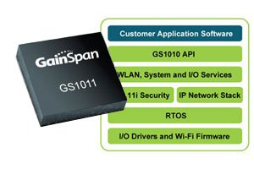**Internet of Things Hardware:**

**Wireless SoC (system on chip)**

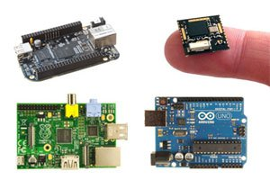

**Prototyping boards and platforms**

**HOW BUSINESS FIT INTO THE IoT**

Much of the talk so far about the Internet of Things has focused on the benefits to consumers, rather than businesses. But in the same way as the original internet has delivered huge efficiency savings to the corporate world, the Internet of Things will underpin radical innovation in how organizations operate. Connecting the physical world to the internet opens up enormous possibilities, limited only by our imaginations.

The key demands of the Internet of Things to connect, communicate and interact with devices wherever they are located fit closely with, for example, much of Electron Technology’s portfolio. Electron’s brands currently focus on the areas that matter most in today’s always-on, networked economy. As their products develop and underpin the Internet of Things through their sensors, connectivity, instrumentation and monitoring technologies. Essentially providing the fittings and fixtures of the Internet of Things.

**Connectivity:**  The Internet of Things is always on, wherever sensors and devices are located. Bulgin’s connectors already operate in the most hazardous and challenging environments, protecting power, Internet and Ethernet cables in areas as diverse as mines and under the sea. With more and more smart devices operating within the Internet of Things, safeguarding them will be crucial. Bulgin’s market leading range will be central to providing cost-effective protection to smart devices, wherever they are located.

**ARE ENTERPRISES READY FOR BILLIONS OF DEVICES TO JOIN THE INTERNET**

There is one fundamental principle driving expectations for the IoT market, the ability to improve customer experience and relationships management through crating intelligent services informed by sight from collated data. The possibilities for business that fully utilize IoT are endless fault detection, consumable replenishment serving product enhancement and action intelligence.

There are currently more devices connected to the Internet than there are people in the world. The Internet now connects a staggering 10 billion devices today. And this number will continue to grow, as more devices gain the ability to directly interface with the Internet or become physical representations of data accessible via Internet systems. This trend toward interactive device independence is collectively described as the Internet of Things (IoT).

The impact of the IoT on healthcare is already significant.  This includes everything from patient check-in using a “virtual” electronic medical record such as a tablet to tracking hospital medical equipment, teaching surgery procedures remotely using Google Glass or outpatient self-help and care.

**The Internet of Things Is Here**

The Internet of Things (IoT) is increasing the connectedness of people and things on a scale that once was unimaginable. Connected devices outnumber the world's population by 1.5 to 1. The pace of IoT market adoption is accelerating because of:

* Growth in analytics and cloud computing
* Increasing interconnectivity of machines and personal smart devices
* The proliferation of applications connecting supply chains, partners, and customers

The Internet of Things (IoT) is here today in the devices, sensors, cloud services and data your business uses.

**Wearables & Internet of Things**

Wearables & Internet of Things Studio was created to bring to life technology solutions for the ecosystem of wearable devices and other applications of the internet of things**.**

With the products developed in this Studio, we are able to gather information about behavior, activities and sensor collected data, and then process all that information to develop new products and services.  
The service practices we provide through our Wearable & Internet of Things Studio include:

* Wearable application usability and interface design
* Native wearable and embedded development
* Hardware design and integration
* Data, design and management

[**https://www.raspberrypi.org/help/what-is-a-raspberry-pi/**](https://www.raspberrypi.org/help/what-is-a-raspberry-pi/)

[**http://en.wikipedia.org/wiki/Raspberry_Pi#Software**](http://en.wikipedia.org/wiki/Raspberry_Pi#Software)

[**https://www.google.co.za/search?q=raspberry+PI+hardwares&biw=1920&bih=985&tbm=isch&tbo=u&source=univ&sa=X&ei=8ClgVf26I-Wy7QbAzIGwBg&ved=0CFMQsAQ#imgrc=OyoRBRyvqDaftM%253A%3BSNbbiSzG13Rp7M%3Bhttp%253A%252F%252Fdlnmh9ip6v2uc.cloudfront.net%252Ftutorialimages%252FRaspberryPi%252FPi-board-labeled.jpg%3Bhttps%253A%252F%252Fgloblib4u.wordpress.com%252F2013%252F06%252F09%252Fraspberry-pi-arch-linux-arm-tutorial%252F%3B600%3B500**](https://www.google.co.za/search?q=raspberry+PI+hardwares&biw=1920&bih=985&tbm=isch&tbo=u&source=univ&sa=X&ei=8ClgVf26I-Wy7QbAzIGwBg&ved=0CFMQsAQ#imgrc=OyoRBRyvqDaftM%253A%3BSNbbiSzG13Rp7M%3Bhttp%253A%252F%252Fdlnmh9ip6v2uc.cloudfront.net%252Ftutorialimages%252FRaspberryPi%252FPi-board-labeled.jpg%3Bhttps%253A%252F%252Fgloblib4u.wordpress.com%252F2013%252F06%252F09%252Fraspberry-pi-arch-linux-arm-t)

[**http://www.cnet.com/how-to/25-fun-things-to-do-with-a-raspberry-pi/**](http://www.cnet.com/how-to/25-fun-things-to-do-with-a-raspberry-pi/)

[**http://www.raspberrypi-spy.co.uk/2012/03/hardware-specification/**](http://www.raspberrypi-spy.co.uk/2012/03/hardware-specification/)

[**https://www.cl.cam.ac.uk/projects/raspberrypi/tutorials/robot/breadboard/**](https://www.cl.cam.ac.uk/projects/raspberrypi/tutorials/robot/breadboard/)

[**https://www.cl.cam.ac.uk/projects/raspberrypi/tutorials/robot/breadboard/**](https://www.cl.cam.ac.uk/projects/raspberrypi/tutorials/robot/breadboard/)

<https://learn.sparkfun.com/tutorials/what-is-an-arduino>

<http://www.arduino.cc/en/Guide/Introduction>

[**http://postscapes.com/internet-of-things-technologies**](http://postscapes.com/internet-of-things-technologies)

[**http://blogs.lse.ac.uk/mediapolicyproject/2014/08/22/the-internet-of-things-what-is-it-and-what-does-it-mean-for-you/**](http://blogs.lse.ac.uk/mediapolicyproject/2014/08/22/the-internet-of-things-what-is-it-and-what-does-it-mean-for-you/)